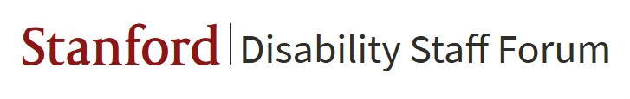
Meeting Summary 11/18

DSF met to discuss programming for the next year and goals:

- How to highlight intersectionality of disability and monthly awareness months
- DSF is a support group for individuals with disability and wants to provide visibility for all varieties of disabilities and experiences
- People have joined DSF for various reasons:
  - Here for social
  - Here for programming
  - Here for action items
- Suggestion to have break-out rooms to work on programming ideas and/or to come and just hang out
- Providing information to the community itself but also to larger community to get people to come to events
- Course on assistive technology: http://web.stanford.edu/class/engr110/
- Peer mentorship program was also suggested

